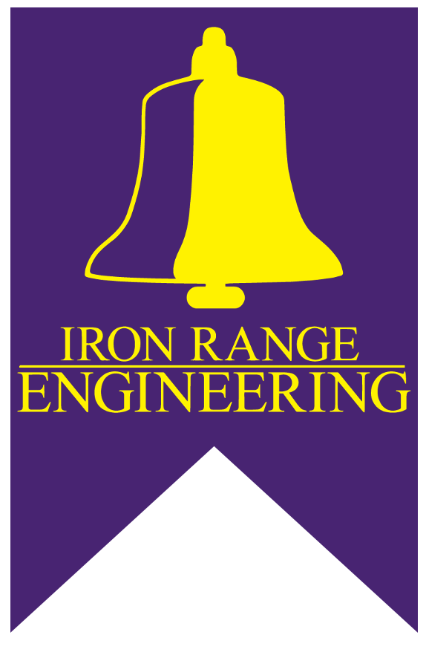
Bell Program | Project Proposal Form

Bell Program Project Proposal Form

We are looking forward to learning more about your project to help our students learn engineering by doing engineering. Please fill out the information below, and we will get back to you shortly.

Proposed Project Title:

Year:

Semester (Fall or Spring):

Project Location:

Proposing Organization:

Address:

Proposer:

Email:

Cell Phone:

Person in Organization Assigned as Client Contact:

Email:

Cell Phone:

Project description (1 paragraph summarizing project):

List of specific desired deliverables at end of project:

Anticipated length of project (1 or 2 semesters):

Areas of engineering technical knowledge that students will need to complete the project (select from list below):

____ Dynamic Systems ____ 3-Phase Systems
____ Fluids ____ AC
____ Heat Transfer ____ Controls
____ Manufacturing Processes ____ Digital Logic
____ Material Science ____ Electronics
____ Mechanics of Materials ____ Electronic Machines
____ Structures ____ Instrumentation
____ Thermodynamics ____ Signals and Systems
____ Entrepreneurial Thinking
____ Statics

Design Software (list here):
Other (list here):

Educational Scope:
Iron Range Engineering Bell Program (IRE-Bell) student projects are meant to serve two purposes: 1. Provide engineering students with an experience that enables them to develop project management skill, technical expertise, design experience, and professional competency
2. Contribute, in a meaningful way, to the client by meeting the client’s defined need.

Process:
At the beginning of the semester, students and their IRE-Bell faculty mentor will meet with the client in a scoping meeting to identify deliverables, constraints, timelines, and resources. At this time the project team and the client will agree on periodicity and types of communication to take place during the project. After the scoping meeting, students perform background research, complete a scoping document, develop options, design experiments and models to test the options, select an option, and execute the design to meet their client’s deliverable needs. Each student spends 10 hours per week working on this process. These design projects are often equivalent to what a single engineer in industry can do in 2 weeks. At the end of the semester, the students will have created a significant technical document detailing their design process, they will present their technical document as well as the design deliverables to the client in a formal presentation.
Elements to a Successful Project:
- Meaningful and realistic projects
- Clearly defined expectations
- Responsive communication in both directions
- Multiple opportunities for students to connect with engineers and technicians

Thank you! Please email this form to bellprogram@ire.minnstate.edu and we will reach out to you shortly!

